Mann PBIS Common Area Matrix
Universal Attention Signal: Raised Hand
Common  Area | 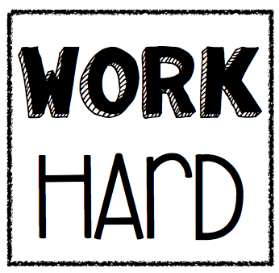 | 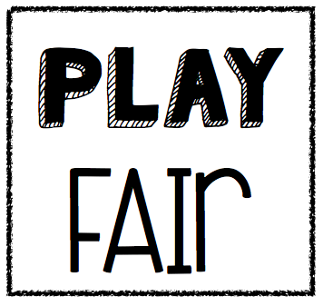 | 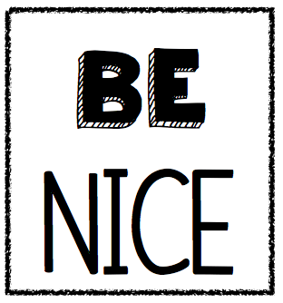
Lunchroom | - I clean up after myself.  - I keep food and trays where they belong.  - I follow adult directions. | - I take what I ordered.  - I eat my own food. | - I use good manners.  - I use an inside voice.  - I stay in my personal space.
Playground | - I play safely.  - I follow adult directions.  - I return equipment. | - I play fair.  - I tell the truth.  - I follow the rules. | - I include others.  - I am a good sport.  - I wait my turn.
Hallway | - I walk safely and quietly.  - I walk on the right side of the hallway. | - I go where I am supposed to go right away.  - I listen and follow adult directions the first time. | - I greet others with a smile.  - I keep my hands and feet to myself.  - I use an inside voice.
Restroom | - I go, flush, and wash.  - I keep my hands, feet, and eyes to myself. | - I respect the privacy of others.  - I go back to class quickly, quietly, and safely. | - I keep the restroom clean.  - I go quickly so that others may go too.
Bus | - I sit facing forward.  - I follow bus safety rules.  - I report problems to the driver. | - I sit where I am assigned.  - I stay in my personal space. | - I greet the bus driver.  - I listen and follow the driver’s directions the first time.  - I get on and off safely.
Dismissal | - I remember my backpack.  - I clean up my coat area. | - I wait for my teacher to dismiss me.  - I go where I belong right away. | - I hold the door for others.  - I walk quietly.

